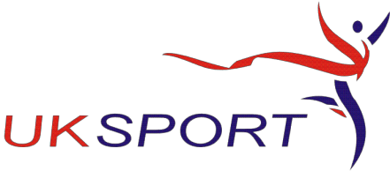
British Taekwondo Council Ltd

Northern Office
130 Barrows Green Lane. Widnes Cheshire WA8 3JJ Tel: 0151 424 9466
email: beddows64@btinternet.com • Website: www.britishtaekwondocouncil.org

.
INDEMNITY INSURANCE APPLICATION FORM

Please complete in BLOCK CAPITALS

Name  Click or tap here to enter text. | Grade  Click or tap here to enter text.
……………………………………………………………………………...................................  Date Of Birth  Click or tap here to enter text. | Association  Click or tap here to enter text.
……………………………………………………………………………...................................  Home Address  Click or tap here to enter text.  ……………………………………………………………………………...................................  Town  Click or tap here to enter text.  ………………………………………………………………………………………………………………  County  Click or tap here to enter text.  ……………………………………………………………………………………………………………….  Post Code  Click or tap here to enter text.  ……………………………………………………………………………...................................  E mail  Click or tap here to enter text. | Club Name  Click or tap here to enter text.  ………………………………………………………………………………………………………..  Club Address  Click or tap here to enter text.  ………………………………………………………………………………………………………..  Town  Click or tap here to enter text.  ………………………………………………………………………………………………………..  County  Click or tap here to enter text.  ………………………………………………………………………...............................  Post Code  Click or tap here to enter text.  ………………………………………………………………………...............................
.…………………………………………………………………………...................................  Tel No Click or tap here to enter text.  ……………………………………………………………………………………..........................  Mobile Click or tap here to enter text. | Club Website  Click or tap here to enter text.

Insurance Information

INDEMNITY | £5,000,000
PUBLIC LIABILITY | £10,000,000

INSTRUCTOR STATUS please mark with X | NEW APPLICATION  ☐ | RENEWAL  ☐

Please sign and return to your Association

I wish to apply for Indemnity Insurance as available to NGB instructors. I declare that to the best of my knowledge there are no known incidents or circumstances that might give rise to a claim or lead to my application being refused by the British Taekwondo Council.

I confirm that I have a current First Aid certificate ☐ and a BTC Basic Safeguarding Awareness certificate ☐
First Aid certificate expiry date: Click or tap here to enter text.

Click or tap here to enter text. Click or tap here to enter text.
Signature: ………………………………………………………………………………. Date: ………………………………………….

Registered Office: 18 Mulberry Avenue. Turnstone Business Park. Widnes. Cheshire WA8 0WN Recognised by the Sport England as the Governing Body for Taekwondo in the United Kingdom
BTC Ltd Registered Company No 07428946

