BTC CLEAN SPORT Education Strategy POLICY

Introduction

British Taekwondo Council (BTC) is recognised as the National Governing Body for Taekwondo in the UK. It was established in 1988 and currently has 14 Member Organisations which practice ITF, Independent and Kukkiwon styles, with clubs in England, Scotland, Northern Ireland and Wales. BTC represents grassroots Taekwondo participants, with some members representing their club and organisation at national and international level. BTC has been working with Sport England as a funded System Partner since 2009 and are compliant with Tier 3 of the National Code for Sports Governance (2021).

BTC works hard to achieve and maintain the requirements of other national Frameworks, including Safeguarding Children in Sport, Safeguarding Adults in Sport, Moving to Inclusion and, as detailed in this document, our Clean Sport Education Strategy and accompanying Implementation Plan, we are committed to achieving compliance with the UKAD Assurance Framework and to preserve the spirit of sport as described in the introduction to the World Anti-Doping Code.

BTC has appointed a Board Anti-Doping Lead, and the responsibility for operational implementation is assigned to the Chief Executive Officer, Trevor Nicholls. Both have completed the relevant UKAD Clean Sport Education relevant to their roles.

BTC Governance

In line with our Articles of Association and the National Code for Sports Governance, the Board is made up of an Independent Non-Executive Chair, two Independent Non-Executive Directors, the Governance and ESG Leads, two Non-Executive Directors, the Governance and the Welfare and Safety Leads, and three Nominated Non-Executive Directors from eligible Member Organisations. During this last year, BTC recruited a new Nominated Non-Executive Director and another resigned. There are four vacant Board positions, three of which could be appointed in line with the BTC Articles of Association and the Skills Matrix. The Board has 8 members: 2 Independent NEDs (25%), 2 skills-based NEDs (25%) and 4 TKD Nominated NEDs (50%). All Directors are appointed based on their skills. BTC has a strong Executive Team in the CEO (Anti-Doping and EDI Lead), the Finance Officer (also the Lead Safeguarding Officer and Membership Services Lead) and the Coaching Director (Tournaments and Instructor Education). The Executive Team has a wealth of knowledge, not only of Taekwondo and its history globally and in the UK, but in the wider Sport and Physical Activity sector, including other NGBs. Compliance with Tier 3 of the National Code for Sports Governance sits with the Board. BTC has a team of 3 Development Officers who provide a professional and efficient administration service. The executive team and officers undertake the work required to comply with the national frameworks for Moving to Inclusion, Safeguarding Children and Adults in Sport, DBS vetting and barring checks as well as the UK Anti-Doping framework. The CEO is the BTC Anti-Doping Lead and responsible for producing an Anti-Doping Annual Review, which is reported to the Board, Membership Services and is publicly available on the BTC website.

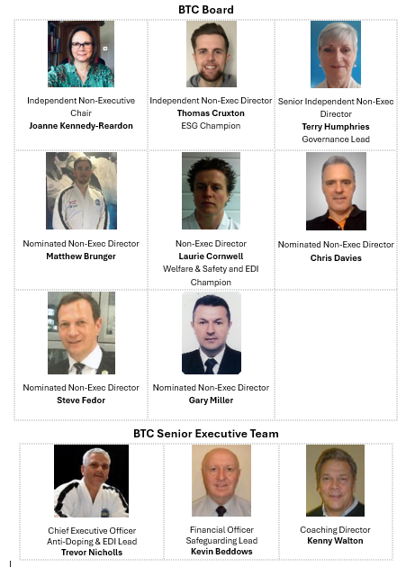

- Current Position
BTC are committed to maintaining our focus, and that of our members, on the Clean Sport Strategy. Links to the UKAD educational programme for Athletes, Coaches and ASPs, and information about testing are available on the BTC website. The testing protocol is accessible to Member Organisations, their Coaches and Athletes (national and international) who may be subject to testing at competitions.
BTC cannot report on anti-doping education which may have been undertaken by Athletes, Coaches or ASPs. BTC now deliver our NGB education and accreditation direct to coaches/instructors and club welfare officers. As we move towards a blend of face-to-face and online learning, BTC will include Clean Sport Education programmes for the Mandatory Groups and will be able to report on take-up. BTC currently communicate with Athletes achieving medals at the BTC Championships and their Coaches/Instructors via their BTC Member Organisations.
BTC continue to engage with GB Taekwondo with a view to agreeing a new Elite Pathway from grassroots to Olympic podium. If we achieve this, our Clean Sport Education Strategy will become a core element of the requirements for Athletes, Coaches and ASPs. BTC will engage with GB Taekwondo, who are the UK Sport and UKAD recognised body for the management of the National TUE Pool and Athletes Returning from a Sanction in Taekwondo.

1.1 Risk Analysis
STRENGTHS | WEAKNESSES
* BTC's CEO, whose knowledge of the sport, Member Organisations and history of the NGB is comprehensive  * BTC has a Board AD Lead  * BTC will utilise UKAD's funded eLearning as a cost effective way of reaching mandatory and options groups  * BTC Member Organisations which are active in their International Affiliations have GB selection criteria and events  * BTC provide Clean Sport information and education links on the NGB website for Athletes, Coaches and ASPs  * Social media messaging prior to BTC Championships  * BTC communicates directly with the coach/instructor workforce and Clean Sport messaging is promoted | * Current BTC education delivery needs to embrace more accessible and bite-sized education via online platforms for our coach/instructor workforce, which is predominantly part-time and voluntary  * BTC elite athletes are not currently included in the GB Taekwondo Talent Pathway  * BTC Member Organisations taking elite athletes abroad should be aware that the governance and alliance of other national sports organisations with the IOC which may require that their athletes are subject to anti-doping testing and the risk of ADRVs
OPPORTUNITIES | THREATS
* BTC and BT are working with BUCS to lead on the delivery of Universities competition  * BTC athlete participation in the Fighting Chance programme with BT and GB Taekwondo would enable BTC, through Member Organisations and Clubs, to promote Clean Sport education  * BTC are exploring professional coaching qualifications with BT which will embed Clean Sport education | * Increasing prevalence of recreational drug use at the community level  * Reduced appetite at grassroots level for contact disciplines within martial arts  * Increased concerns in health, sport and communities about the risks of concussion  * Prevalence of a 'win at all costs' attitude within the highly competitive participants in martial arts, including coaches as well as athletes

1.2 Sports System and Significant Partners

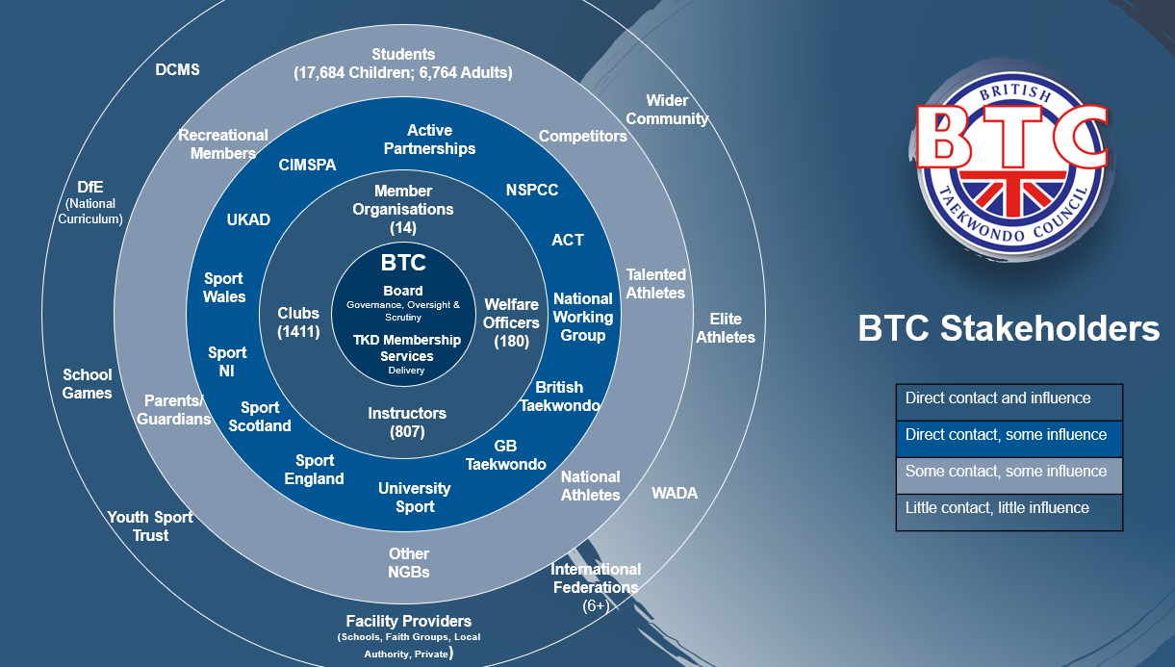
At the end of January 2026, the total number of Taekwondo participants was 24,935, marking a slight increase (1%).
1.3 Identification of Target Groups
Mandatory Groups – Education Programme Audience | Approx No of Athletes | Approx No of ASPs
Fighting Chance and/or those athletes competing at the highest level in the sport, including ASP core influencers | 40 | 20
BTC MO International Reps, including ASP core influencers | 280 | 200
BTC National Medalists, including ASP core influencers | 720 | 600
BTC Development Squad, including ASP core influencers | 1440 | 1000

2.0 Clean Sport Curriculum
As the number of BTC athletes falling into the above categories is very small, it has been agreed with UKAD that BTC athletes, coaches and ASPs in the mandatory groups will participate in UKAD Clean Sport education, which should be renewed every two years whilst involved in active competition at national and international level.

3.0 Education Programme
BTC athletes, coaches and ASPs will be directed to the UKAD Clean Sport education programme:
- Clean Sport Values
- Building a Clean Sport Culture
- Understanding Causes of Doping
- Challenging Situations and Support Channels
- Image and Performance Enhancing Drugs (IPEDs)
- Psychoactive Drugs
- Understanding Anti-Doping and How It is Governed
- The Prohibited List
- Anti-Doping Rule Violations (ADRVs)
- Consequences of Doping
- Testing Procedures
- Testing Pools
- Checking Medications
- Therapeutic Use Exemptions (TUEs)
- Food First and Supplements
- Protect Your Sport
Clean Sport education can be delivered in a variety of ways, and at a level which achieves the learning outcomes required, ie:
- Awareness (grassroots, Member Organisation Development squads, parents/carers/ guardians)
- Understanding (national medalists, ASPs)
- Application (international, Fighting Chance and world class competitors, ASPs)
4.0 Education Programme Audience
Education Delivery Resources | ASPs, inc Parents / Carers / Guardians | Coaches | BTC/MO Development Squads | BTC National Medalists | BTC Member Organisation International Reps | Fighting Chance and world class competitors
Social Media
BTC Webpage
MO/Instructor newsletter
UKAD ASP Clean Sport
UKAD 100% me
UKAD Compete Clean+ elearning

5.0 Resources: Workforce and Financial
As described in the BTC Strategy, the BTC workforce within the NGB function is 5, who have the active support of the 3 NEDs supporting Welfare and Safety, Finance and Governance. Considering the low number of BTC athletes, coaches and ASPs who are likely be subject to Clean Sport Education as detailed in this policy, BTC and UKAD have agreed that it is more efficient and cost effective that BTC members engage directly with the UKAD education programme rather than upskill a member of the NGB team, at this time, to become a qualified Anti-Doping Educator.
BTC will recognise Clean Sport Education delivered by other sports and organisations where either the training provider can produce a signed register or a certificate for the named individual.
6.0 Strategic Clean Sport Priorities and Implementation Plan
BTC’s strategic Clean Sport priorities are as follows:
Short term: Share information via Member Organisation and Instructor emails and newsletters with links to the BTC Clean Sport Education Strategy when approved by the Board and published on the BTC website
Infographic to be shared via BTC Facebook and Instagram to reach grassroot participants and ASPs
Annually share the Prohibited List with relevant groups and BTC website
Promote Clean Sport Week in May annually
BTC social media pages to follow @ukantidoping and share relevant information
Medium term: Develop communications for sharing with all BTC members prior to BTC Championships via different platforms
Add Clean Sport Education to BTC Registered Instructor online CPD options for Coaches of talented athletes, to be renewed every 2 years
Share updates to the Code with relevant groups as and when these are available
Long term: If BTC achieves a direct route to GB Taekwondo for our elite athletes, we will ensure that they are prepared for their continued development and competition opportunities with UKAD learning outcomes embedded in their BTC Taekwondo journey
7.0 Monitoring and Evaluation
BTC will work with UKAD and use registers and other relevant IT tools to monitor attendance to courses. This information will be held in accordance with the BTC Data Protection policy and will be shared with UKAD when requested. BTC will use surveys and UKAD data to evaluate the effectiveness of this Clean Sport Education Strategy, the Implementation Plan and achievement of the learning outcomes by the mandatory groups.

Amendment Log
Date | Change | Made by | Approved by
Sep 2024 | First version | T Humphries | BTC Board
Mar 2026 | Full review and updated throughout | T Nicholls / T Humphries

Approved date: 10th October 2024
Review date: October 2027

