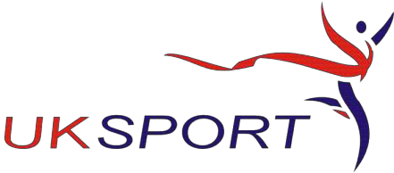

British Taekwondo Council

Northern Office
130 Barrows Green Lane. Widnes Cheshire WA8 3JJ
Tel: 0151 424 9466
email: kevin@tkdcouncil.com • Website:www.tkdcouncil.org

.

DBS Application Form

For instructors in England, Wales, Channel Islands and the IOM

Please complete in BLOCK CAPITALS

Full Name
NB: As shown on your passport Click or tap here to enter text.
D.O.B Click or tap to enter a date.
Association Click or tap here to enter text.
Home Address Click or tap here to enter text.
Town Click or tap here to enter text.
County Click or tap here to enter text.
Post Code Click or tap here to enter text.
Tel No Click or tap here to enter text.
email address Click or tap here to enter text.

Please complete this form and return it along with your Registered Instructor Application form by email to kevin@tkdcouncil.com

Signature: Click or tap here to enter text. Date: Click or tap to enter a date.

